Experiment worksheet

6.1 All living things are made up of cells

Pages 96–97 and 196

Skills lab 6.1: Drawing cells

Several stations are set up around the laboratory with microscopes adjusted to show different kinds of cells.

**DO NOT ATTEMPT TO ADJUST ANY OF THE MICROSCOPES!** ASK YOUR TEACHER OR LABORATORY TECHNICIAN TO ADJUST THE MICROSCOPE IF YOU THINK IT HAS BEEN BUMPED OR HAS GONE OUT OF FOCUS.

What to do

1 Look carefully at each specimen. Write down its name and a sentence that describes what you see.

2 Make a very simple pencil sketch of a single cell that you can see. Draw the outside edge of the cell first, including any bump or unusual shape you notice.

|  |
| --- |
|  |

3 Draw two more cells that are close to your original cell. (Do not attempt to draw every cell that you see.)

4 If you can see anything inside the cells (it may only be a dark dot), mark this on your sketch.

5 Label any parts that you can identify.

• Which cells, in your opinion, were the most unusual?

• Which cells had very obvious walls around them?

• Which cells were the smallest?

• Which cells were the largest?

• How did your view through the microscope compare with the images of the cells below?

• Describe some of the difficulties of drawing cells seen through a microscope.

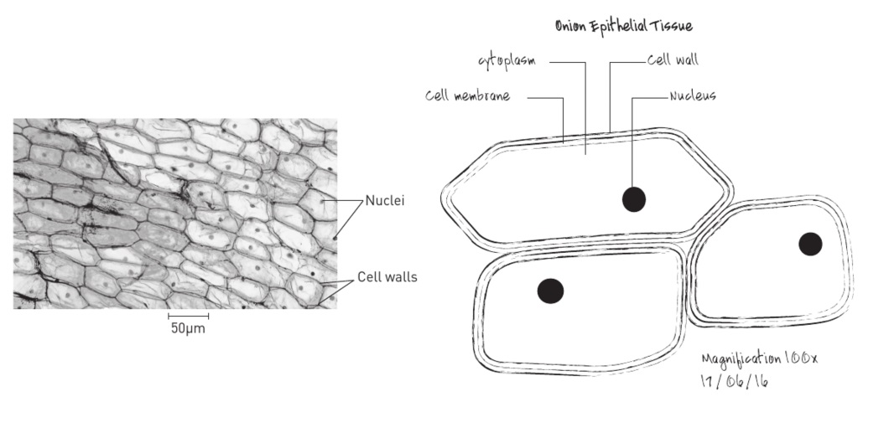Experiment worksheet

6.2 Microscopes are used to study cells

Pages 98–99 and 197

Skills lab 6.2: Getting to know your microscope

What you need

• Compound light microscope

• Microscope slide

• Coverslip

• Small piece of newspaper

• Eyedropper

• Small beaker of water

• Small piece of tissue paper

• Hair (use your own)

• 1 cm sticky tape (transparent)

What to do

1 Always use two hands to carry a microscope – one hand should be around the main part of the instrument and the other underneath it.

2 Some microscopes have a built-in lamp. Others have separate lamps that need to be set up so they shine onto the mirror. Adjust the mirror to project the light through the stage onto the specimen. Do not allow sunlight to shine directly up the column.

3 Place the slide on the stage then select the objective lens with the lowest magnification first.

4 Cut out two small words from a piece of newspaper.

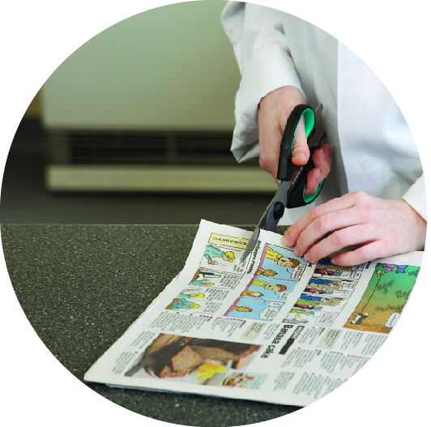

**FIGURE 1** Use scissors to cut out words from the newspaper

5 Place the cut-out newspaper on the microscope slide and add two drops of water to help it ‘stick’ to the slide. Place coverslip on top. This is called a wet mount.

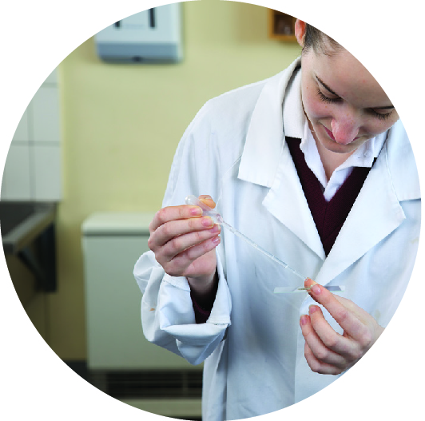

FIGURE 2 Gently lower the glass coverslip down until it is flat

6 Look from the side and adjust the coarse focus knob so that the objective lens is just above – and not touching – the slide. Check which way you must turn the knob to move the objective lens away from the slide.

7 Use the coarse focus knob to bring the specimen into view. Find one letter from the newsprint to focus on.

8 Move the slide slightly towards your body and observe what happens.

9 Move the slide slightly to the left and observe what happens.

10 Increase the magnification by rotating the objective lens to a higher magnification.

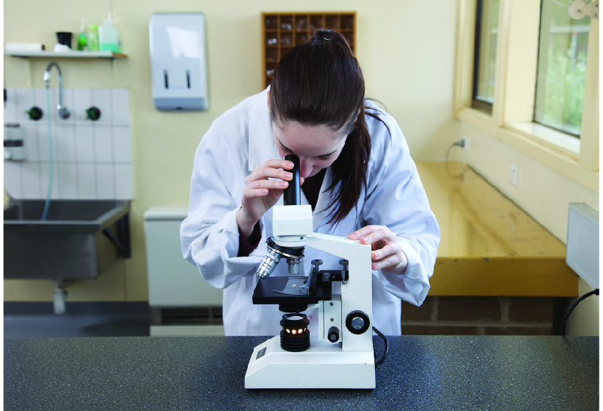

**FIGURE 3** Carefully adjust the focus of the microscope

11 Draw a diagram of the newspaper letter (as a record) using a sharp lead pencil in the space provided. Never colour or shade areas; if absolutely necessary, use dots or lines instead.

|  |
| --- |
|  |

12 Work out the total magnification.

13 Write the magnification next to your sketch.

14 Label and date the sketch.

15 Take the newspaper out and prepare another slide using the tissue paper. Make sure a drop of water is added and the coverslip is placed over the top carefully.

16 Sketch what you see using the space provided.

|  |
| --- |
|  |

17 Repeat with sticky tape and then a hair from your head.

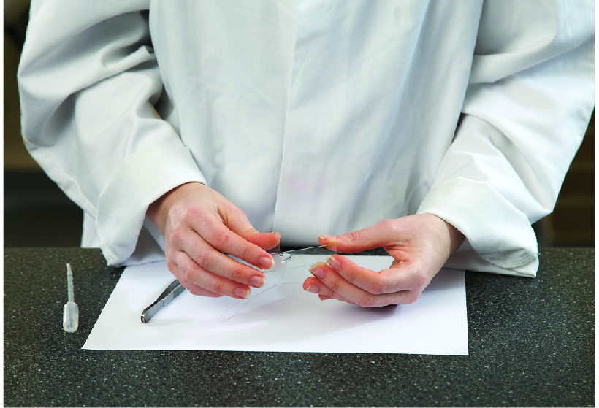

FIGURE 4 Examine a hair under the microscope.

Questions

1 Describe what the newspaper letter looks like through the microscope. What does this mean for all things you see through this type of microscope?

2 What features could you see on the tissue paper and sticky tape that you could not see with the naked eye?

3 Use a series of cause-and-effect graphic organisers, similar to that shown in Table 1, on a separate sheet of paper record the results of your experiment when you moved the slide different ways. For example, the cause link may be ‘move the slide to the left’. Then write what happened in the effect link.

Table 1Cause-and-effect graphic organizer

|  |  |  |
| --- | --- | --- |
| Cause | 🡪 | Effect |
| What did you do to cause the change you observed? | 🡪 | What effect did it have? |

Experiment worksheet

6.3 Plant and animals cells have organelles

Pages 100–103 and 198

Challenge 6.3: Comparing the size of cells and their parts

What you need

• Sheet of poster paper

• Pencil

• 30 cm ruler

• Eraser

What to do

PART A

1 Using a scale of 1 cm : 1 μm, draw a series of circles to represent the average size of various cells and microbes according to the measurements given in Table 1.

|  |
| --- |
|  |

Table 1Average diameters of different cell types.

|  |  |
| --- | --- |
| Cell type | Averge diameter (µm) |
| Human cheek cell | 30 |
| Human red blood cell | 7 |
| Human white blood cell | 25 |
| Epidermal plant cell | 50 |
| Staphylococus bacterium (spherical) | 1 |
| Escherichia coli bacterium  (rod shaped) | 3 |

2 Rank the cells and microbes from smallest to largest.

PART B

Organelles vary in size. Some organelles, such as chloroplasts, are large enough to be visible under the light microscope. Others, such as mitochondria, are usually too small to be visible.

1 Use the measurements given in Table 2 to add a chloroplast and a mitochondrion (singular) to your set of diagrams.

Table 2Size of cell organelles.

|  |  |
| --- | --- |
| Cell Organelle | Averge size (µm) |
| Chloroplast | 5µm long x 1.5µm wide |
| Mitochondrion | 2µm long x 1µm wide |

1 Which of the cell organelles in Table 9.19 are not visible under the light microscope?

2 Viruses are much smaller than even bacterial cells. For example, the influenza virus, which causes the flu, is 0.1 μm in diameter. Add the influenza virus to your diagrams.

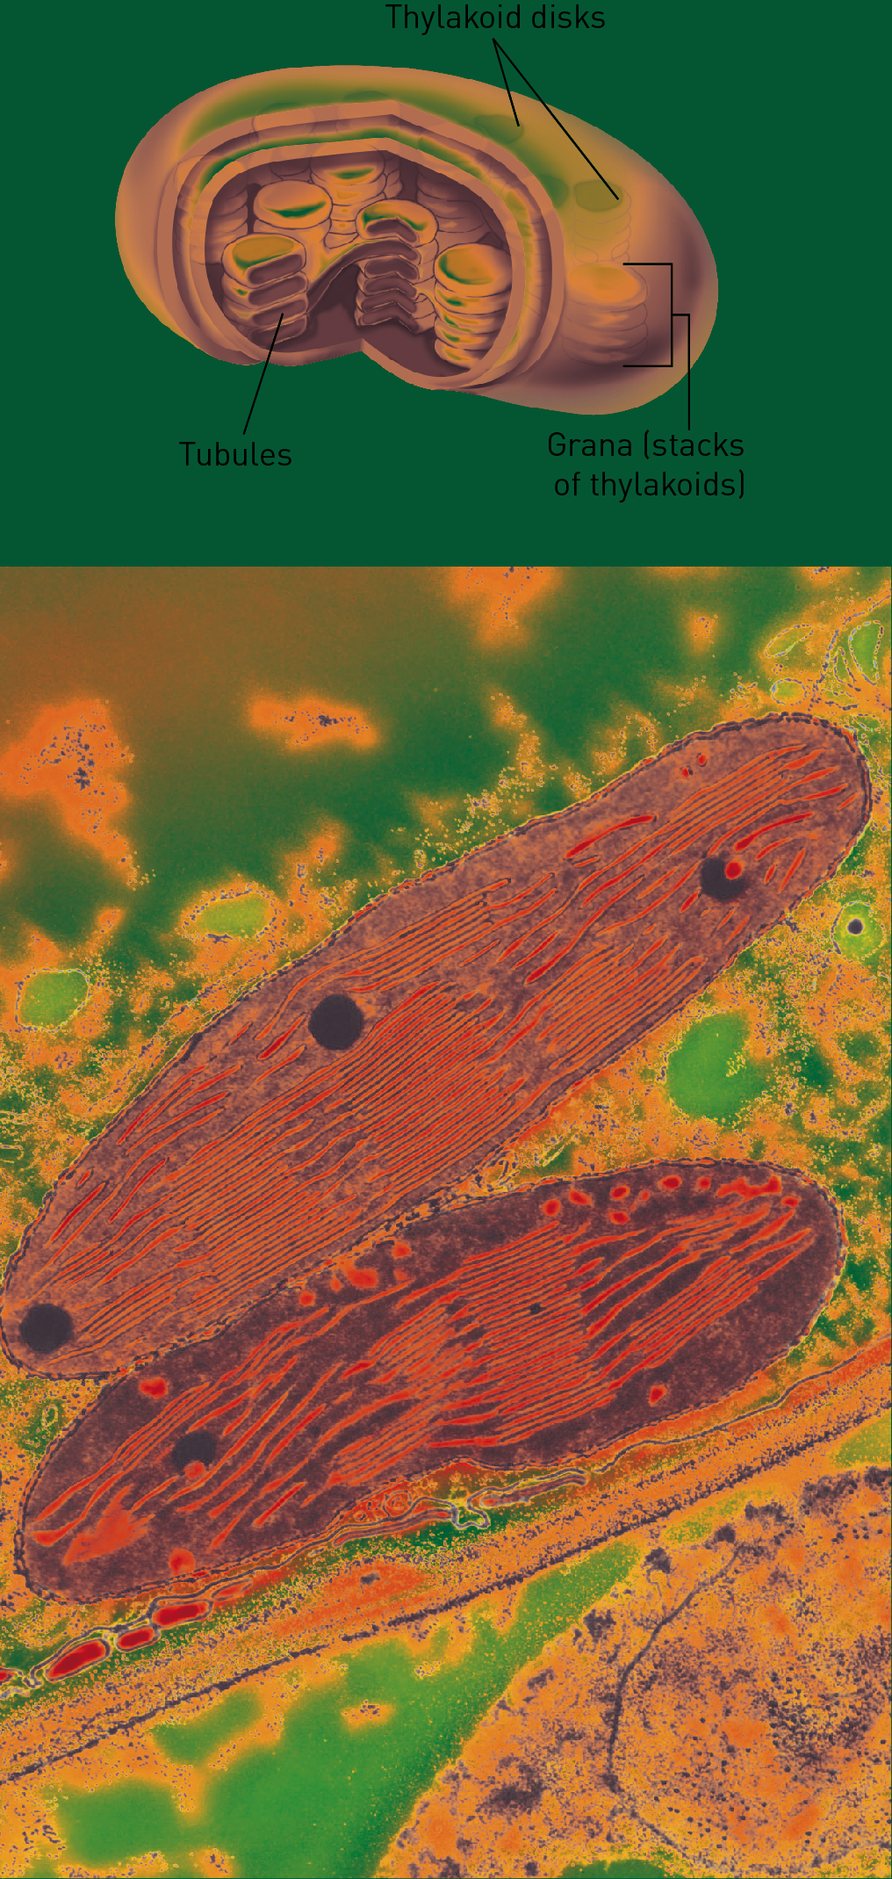

Figure 3 (a) Schematic diagram showing the structure of a chloroplast. (b) Electron micrograph of a chloroplast.

Experiment worksheet

6.3 Plant and animals cells have organelles

Pages 100–103 and 199

Experiment 6.3A: Looking at organelles

Aim

To prepare slides to view the organelles in the cells of a brown onion and an *Hydrilla verticillata* plant. You may wish to review Experiment worksheet Skills lab 6.2: Getting to know your microscope for slide and microscope use.

Materials

• Onion wedge

• Three glass slides

• Three glass coverslips

• Water

• Light microscope

• Methylene blue stain or iodine

• Leaf from an *Hydrilla verticllata* plant

• Blotting paper

Method

ONION SKIN CELLS – UNSTAINED

Light microscopes depend on the light being able to pass through the specimen. When preparing a slide, it is important that the specimen is as thin as possible.

1 Between the fleshy layers of an onion there are some thin, transparent layers. These layers are one cell thick. Peel off a layer of this skin and put it onto a microscope slide.

2 Add one drop of water and then gently lower the coverslip so that no air bubbles are trapped.

3 Draw and label what you see. Try to identify the nucleus, which contains the DNA, and the cell membrane and cytoplasm.

4 Keep this slide for use in the next part of the experiment.

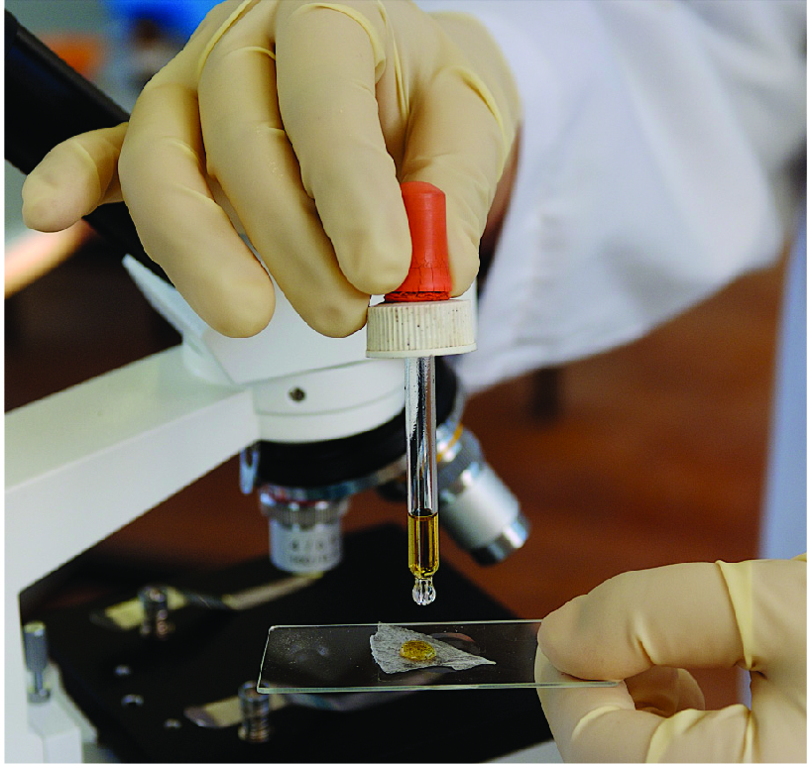

Figure 1 Add a drop of water to the slide then add a coverslip.

ONION SKIN CELLS – STAINED

Stains are often used on specimens because they add contrast to the image. Some highlight a particular feature of the cell.

5 Use another thin layer of onion skin to prepare a second slide as above.

6 Add a drop of methylene blue stain or iodine instead of the water before lowering the coverslip carefully so that no air bubbles are trapped. Be careful not to get the stain on your skin or clothes because it is very hard to remove.

7 Draw and label what you see. How does the use of the methylene blue stain or iodine change the appearance of the onion cells?

*HYDRILLA VERTICILLATA* CELLS

8 Pick a small green *Hydrilla verticillata* leaf and put it onto a microscope slide.

9 Add one drop of water and then gently lower the coverslip so that no air bubbles are trapped.

10 Draw and label what you see. Try to identify the cell membrane and cytoplasm.

11 What other organelle is clearly visible in these cells?

Results

Include your labelled diagrams in this section.

|  |
| --- |
| Onion skin cells – unstained |
| Onion skin cells – stained |
| *Hydrilla verticillata* cells |

Discussion

1 How does the use of a stain change the image of the onion cells?

2 Both types of cells viewed are from plants. Suggest why there are differences between each of the cell types. (Hint: Consider which part of the plant the cells come from.)

3 It is often difficult to identify the nucleus in the *Hydrilla verticillata* cells. Can you suggest why?

4 The *Hydrilla verticillata* cells contain another structure that is very prominent. What could be the role of this structure within the cell?

5 Can you suggest why it is not necessary to stain the *Hydrilla verticillata* cells?

Conclusion

What do you know about the organelles in onion cells and *Hydrilla verticillata* cells?

Experiment worksheet

6.3 Plant and animals cells have organelles

Pages 100–103 and 200

Experiment 6.3B: Measuring cells

Aim

To measure the size of various plant and animal cells using a mini-grid.

Materials

• Onion cell slide (prepared in Experiment 6.3A Looking at organelles)

• Light microscope

• Mini-grid slide or 1 mm graph paper photocopied onto a transparency

• Other various prepared slides, such as human blood, nerve cells, leaf epidermis

Method

1 Focus the onion cells under the light microscope.

2 Once in focus, estimate the average length and width of one cell in relation to the field of view.

3 Gently remove the slide and insert the slide containing the mini-grid.

4 Each box is 1 mm in length. Determine the length of the field of view by counting how many boxes fit across the light field.

5 Use this measurement to calculate the average length of one onion cell by estimating how many cells fit across the light field.

6 Repeat this process for each of the other prepared slides.

Results

Rank the cells viewed in size from smallest to largest.

Discussion

Does your ranking match Table 1 below?

Conclusion

What do you know about the relative sizes of plant and animal cells?

**TABLE 1** Average diameters of different cell types.

|  |  |
| --- | --- |
| Cell type | Averge diameter (µm) |
| Human cheek cell | 30 |
| Human red blood cell | 7 |
| Human white blood cell | 25 |
| Epidermal plant cell | 50 |
| Staphylococus bacterium (spherical) | 1 |
| Escherichia coli bacterium  (rod shaped) | 3 |

Experiment worksheet

6.4 All organisms have cells that specialise

Pages 104–105 and 200

Challenge 6.4: Classifying using cells

What you need

• Light microscope

• Four pre-prepared cells labelled A–D, supplied by your teacher (these may include leaf epidermal cells, yeast cells, protea cells or animal cells)

What to do

1 Look at each slide under the microscope.

2 Using Table 1 to help you, classify each slide into one of the five kingdoms.

Table 1Average diameters of different cell types.

|  |  |
| --- | --- |
| Cell type | Averge diameter (µm) |
| Human cheek cell | 30 |
| Human red blood cell | 7 |
| Human white blood cell | 25 |
| Epidermal plant cell | 50 |
| Staphylococus bacterium (spherical) | 1 |
| Escherichia coli bacterium  (rod shaped) | 3 |

3 Use the table below to present your results.

|  |  |  |
| --- | --- | --- |
| Slide | Average diameter (µm) | Kingdom |
| A | 30 |  |
| B | 7 |  |
| C | 25 |  |
| D | 50 |  |

Experiment worksheet

6.4 All organisms have cells that specialise

Pages 104–105 and 201

Experiment 6.4: Plant and animal cells

Aim

To compare plant and animal cells.

Materials

• Brown onion

• Microscope slide

• Coverslip

• Iodine in dropper bottle

• Light microscope

• Prepared slide of animal cells

Method

1 Peel off a very thin piece of brown onion skin so that it looks a bit like cling film.

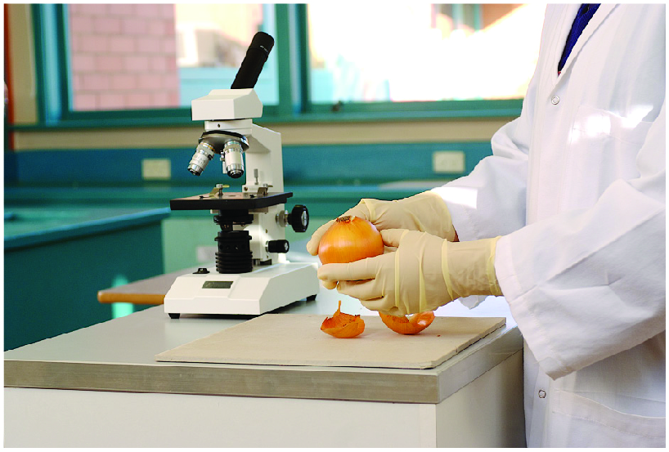

2 Place the skin on the microscope slide and add a tiny drop of iodine. This stains parts of the cells to make them easier to see.

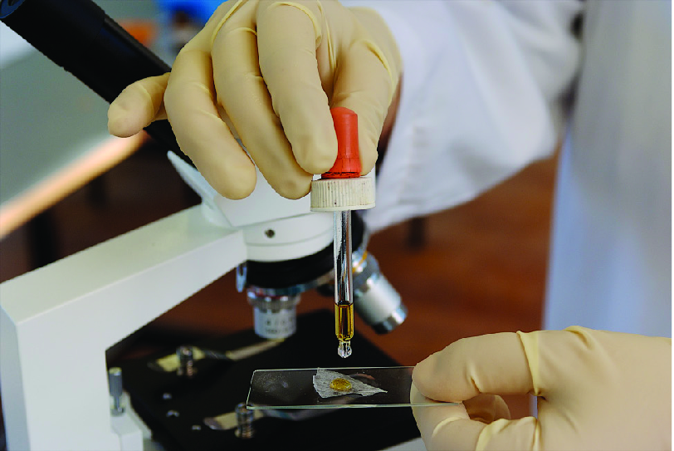

3 Place one edge of the cover slip onto the slide and carefully lower it so that no air bubbles are trapped underneath.

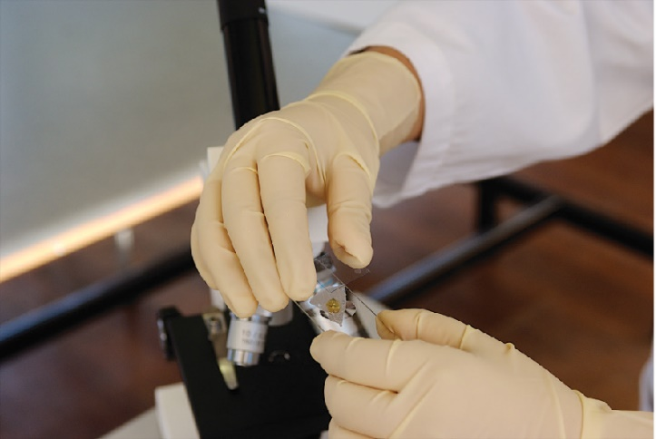

4 Place the slide on the stage.

5 Focus the microscope.

6 Draw the cells you observe. Don’t forget to label your diagram and write down the total magnification

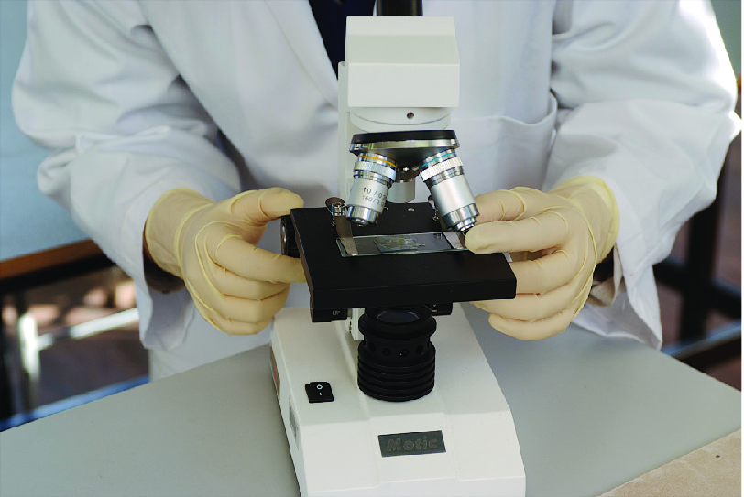

7 Remove the slide and place the prepared slide of animal cells under the microscope. Focus the microscope.

8 Draw the cells you observe.

9 Write down the total magnification and label the diagram.

Results

Include your cell diagrams here.

|  |
| --- |
|  |

Discussion

1 What is the purpose of staining the onion skin cells?

2 What kind of living thing did the onion skin come from?

3 Compare the two sketches you have prepared with the images of plant and animal cells. List any differences and similarities.

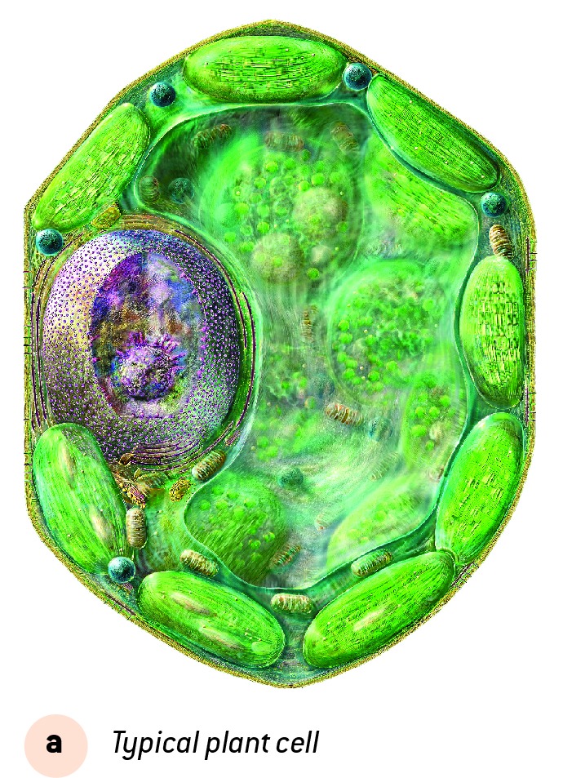 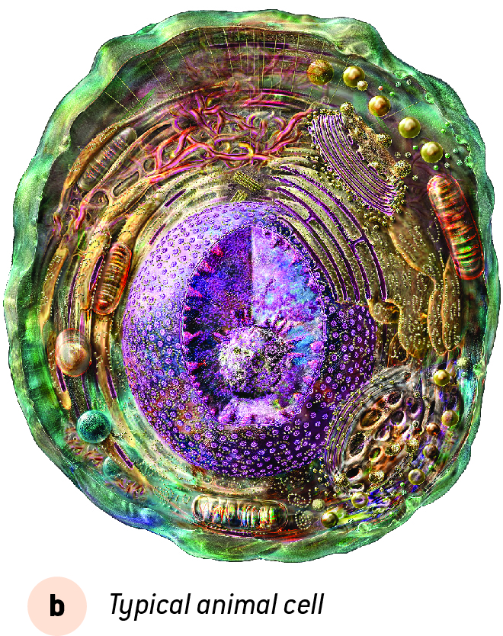

4 Use the Venn diagram in Figure 1 to show how plant and animal cells are similar and how they are different.

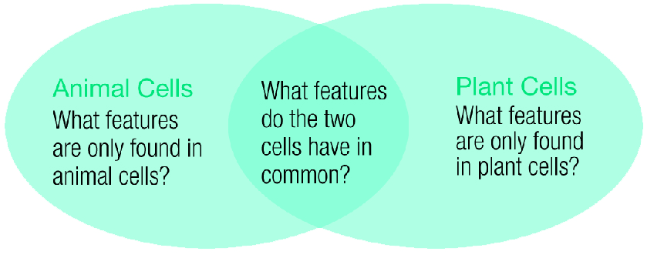

Figure 1What are the similarities and differences between plant and animal cells?

Conclusion

What do you know about plant and animal cells?

Experiment worksheet

6.5 Bacteria are single-celled organisms

Pages 106–107 and 202

Experiment 6.5: Microbes all around

In this activity you will investigate if common detergents can kill the bacteria found in the local environment. Most human pathogenic bacteria and fungi (those that are potentially harmful to humans) grow optimally at 37°C. For this reason, samples should be sealed with paraffin wax or tape prior to incubation and destroyed immediately after analysis.

Aim

To determine the effectiveness of detergents in killing or restricting bacterial growth.

Materials

• 3 Petri dishes (containing nutrient agar)

• 2 sterilised swabs

• Paraffin wax strips

• Incubator

Method

1 Two agar plates are to be used for growing microbes and the third is the negative control plate. The negative control plate should not be opened at any stage of the activity, but must be incubated alongside the sample plates.

2 Decide on a site around the school to be tested for microbes.

3 Keep the swabs sterile (germ free) until you reach the site.

4 Rub the swab over the site and then gently rub it across the surface of the agar in both directions. Take care not to damage the surface of the agar.

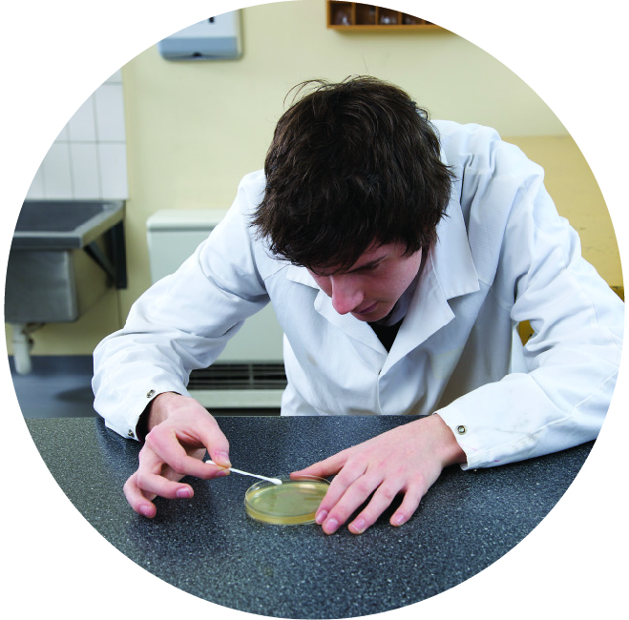

Figure 1 Carefully wipe the swab over the agar plate.

5 Quickly place the lid on the plate, seal it with a wax strip and then incubate it, along with the control plate, at 37°C for 2–3 days.

Inquiry: What if a detergent was spread over the surface of the agar plate?

• Choose a detergent that you would like to test.

• Write a hypothesis for your experiment.

• What (independent) variable will you change from the first method?

• How will you know if the detergent is effective in killing/restricting bacterial growth? (This is your dependent variable.)

• List three variables you will keep the same/control between the three plates.

Record your observations in a table in the space below.

|  |
| --- |
|  |

• At the end of the activity, dispose of the agar plates appropriately

Discussion

1 Describe the growth on your sample plates after the incubation period. A labelled diagram may assist your description. Did you observe the growth of both bacteria and fungi? What were some of the differences between them?

|  |
| --- |
|  |

2 If your sample plate showed evidence of bacterial growth, do you think that there was more than one type of bacteria present? Justify your response.

3 Was your detergent effective in controlling bacterial growth?

4 Suggest why there may be some differences between the growth on your plates and those of other students.

5 Explain why it is important that both the swab and the plate are sterile and are only exposed to the environment for a short period while collecting the sample.

6 If the negative control plate was sterilised appropriately prior to the beginning of this activity and then incubated alongside the sample plate, it should have shown no bacterial or fungal growth. Explain the purpose of the negative control plate.

Conclusion

What do your results conclude about the effectiveness of your detergent?

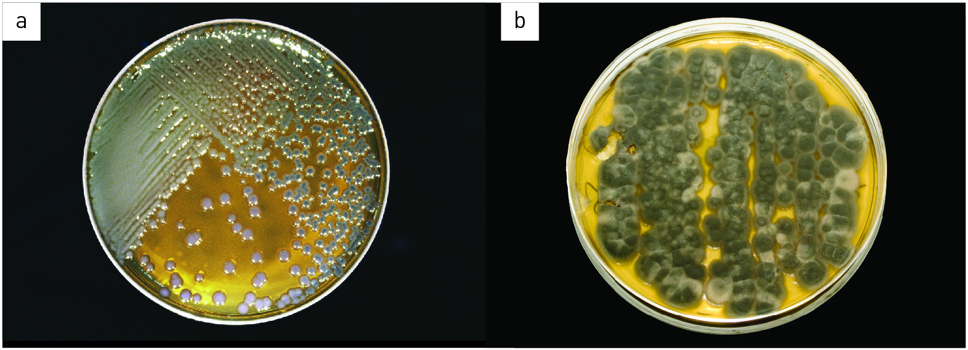

Figure 2 (a) Bacterial colonies growing on an agar plate. (b) Fungi tend to have a dusty or fuzzy appearance.

Experiment worksheet

6.6 Eukaryotic cells undergo mitosis

Pages 108–109 and 203

Challenge 6.6: Modelling mitosis

What you need

• 4 long balloons

• Permanent marker

What to do

1 Blow up one balloon and label it ‘parent cell’.

2 Blow up the second balloon to represent the parent cell becoming larger in preparation for mitosis.

3 Use the two remaining balloons to represent the two daughter cells that result from cell division. Label each of these cells ‘daughter cell’.

Discussion

• How would you represent a cancerous cell?

• How would you represent apoptosis in a balloon cell?